Biological Terrain
The Importance of the Internal Milieu
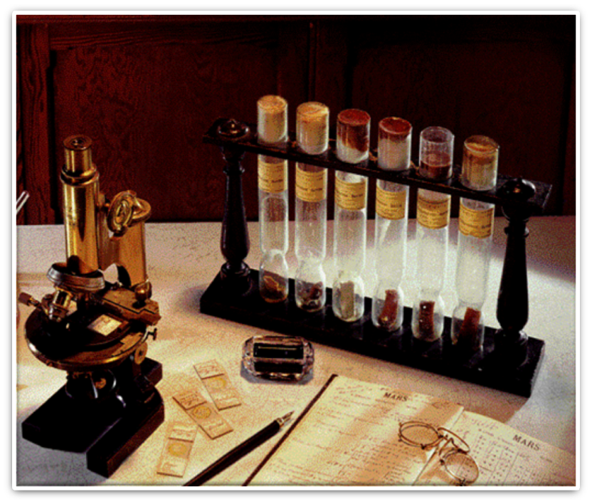
In our culture, disease begins at the onset of symptoms. However, it might well be stated that disease begins when our alkaline tissues turn acidic and when our negative energy charge turns positive. Dr. Arthur C Guyton MD who wrote the Textbook of Medical Physiology (once used in most medical schools) makes this statement:
"The first steps in maintaining health is to alkalize the body (pH or acid/alkaline balance). This is one of the most important aspects of homeostasis. Changes in pH alter virtually all body functions. The cells of a healthy body are alkaline while the cells of a diseased body are below a pH of 7.0. The more acidic the cell, the sicker we become. If the body cannot alkalize the cells they will become acidic and thus, disease sets in. Our bodies produce acid as a by product of normal metabolism. Since our bodies do not manufacture alkalinity, we must supply the alkalinity from an outside source to keep us from becoming acidic and dying"
There is a simple test to illustrate this point. Take a banana and place it on a counter next to a piece of cheese. Place a glass over the cheese so it doesn't dry out too quickly. Now watch them both over the over the next few days. What do you think will happen? The banana starts to turn black and the cheese begins to mold. They go bad. They rot.
Now slice open the cheese. Inside, no mold. Slice open the banana. It's rotten inside. Smell the banana and you'll smell a hint of alcohol. It's fermenting. Most of us probably know this - the cheese molds from the outside in, but the banana rots from the inside out. The banana was alive. The cheese is not alive.
Every living thing comes equipped with it’s own janitorial service that goes to work when it dies. They are programmed by the Vital Force to clean up the substances which are no longer vital. As contrary as it seems, it appears that "germs" are attracted to the diseased tissues, they are not the primary cause of it.
A quote from Dr. Rudolph Virchow, the Father of Modern Pathology, supports this idea: “If I could live my life over again, I would devote it to proving that germs seek their natural habitat - diseased tissue - rather than being the cause of dead tissue. In other words, mosquitoes seek the stagnant water, but do not cause the pool to become stagnant." The symptoms of the flu or pneumonia - fever, chills, cough, and excess mucous production - are actually secondary illnesses; the first “illness” was loss of health in the underlying tissues.
The one hundred trillion cells in the human body are bathed in a nutrient- filled fluid matrix called the Biological Terrain. Other names for this fluid include the interstitial matrix, internal milieu, ground matrix, the garden, etc. This environment, like the soil, feeds and nourishes all of the cells in the body. The outermost wall of every cell is called the cell membrane. This membrane is permeable, which means that certain elements can flow in and out of this membrane. The cells absorb electrolytes, vitamins, minerals, enzymes and fluid in very specific amounts. The cell, to maintain cellular health, creates substances called energy-rich intermediates and then utilizes these nutrients.
The body to produce energy in the form of ATP then uses these substances. ATP is the energy that fuels many critical actions and reactions in the human body. The waste products from these cellular reactions within the cells are then released back into the Biological Terrain for proper filtering and disposal by the body. The integrity of the cell, its cell membrane and the vitality of the Biological Terrain increase the probability that the cell will grow and thrive.
The biological terrain has many important functions:
- The interstitial fluid environment is responsible for delivering nutrients to every cell in the human body. The electrolytes, vitamins, minerals, enzymes, hormones and fluid within the Biological Terrain enables the body's 100 trillion cells to perform all of their vital functions of maintaining life and health.
- The biological terrain is also responsible for carrying energy-rich substances throughout the body for the production of energy or ATP. ATP is the form of energy that is needed to carry out most actions and reactions in the body.
- The movement of minerals from the cells for filtering and disposal by the body. These minerals enter the body's biological fluids of blood, urine, lymphatic fluid and saliva. These fluids serve as indicators of what has been released from within the cells. If the critical balance of pH, nutrient or mineral levels or hydration within the biological terrain becomes disturbed or damaged cellular stress may result. Over time, this may contribute to the development of poor health and increased susceptibility to the effects of opportunistic organisms such as bacteria and viruses. Monitoring the biological terrain provides an inside look at the vital biochemical functions that contribute to maintaining strength and vitality in the body.
When cells live in a healthy biological terrain with balanced pH, nutrient and hydration levels, they will thrive. They may also be better equipped to resist the effects of damaging organisms such as bacteria, viruses, yeast and fungi.
Although the testing procedure does not diagnose any specific pathology or disease states, it does serve as an analytical guide post that tremendously aids in the overall evaluation of the patient.
Most biological terrain practitioners also incorporate many other forms of objective and subjective examinations and evaluations along with Biological Terrain Analysis, eg. EAV, muscle testing, BIA, etc.
The Science of Biological Terrain had its beginnings in Europe over 100 years ago. A French physiologist named Dr. Claude Bernard formulated a theory that the primary cause of most illness and disease was due to imbalances in the underlying biochemistry of the body. He believed that disturbances in the body's "Milieu Interior" or Biological Terrain compromised cellular functioning.
As the Biological Terrain is the interstitial fluid that bathes and nourishes every cell in the human body, Claude Bernard, professor at the Sorbonne and member of the Academy of Science, maintained that the "terrain" is everything. Neither man, Bernard, a physiologist, and Pasteur, a chemist, denied the existence of microorganisms. The question is how the organisms behave and whether or not they invade from outside (Pasteur) or are mainly life forms that behave in different ways depending upon the circumstances, organisms that may not be pathogenic in some conditions.
Dr. Bernard believed that the disturbances or imbalances in this cellular environment affected the entire body including the immune system, (disrupted by today’s toxicities—vaccines, chemicals, heavy metals, processed food, preservatives, etc.) These molecules create a cellular shift toward an acidic state. When cells become acidic, pathogens find a favorable environment to replicate. Over time, a compromised immune system had difficulty fighting disease and maintaining health. This theory later developed into the science known as Biological Terrain.
Dr. Bernard's theory was opposed by Dr. Louis Pasteur. Dr. Pasteur subscribed to the theory that microbes outside of the body, such as bacteria and viruses, caused most illness and disease. These two scientists opposed one another for many years. It appears, that throughout his career, Pasteur had doubts about his own assumptions. On his deathbed, it has been widely quoted that Pasteur said “Bernard avait raison. Le germe n’est rien, c’est le terrain qui est tout.” (“Bernard was right. The germ is nothing; the soil is everything.”). Apparently he had come to the conclusion that Bernard's "Milieu Interior" theory was indeed correct that illness and disease are caused primarily by imbalances in the body's Biological Terrain.
In the many years since Bernard developed his theory, the science and application of biological terrain concepts continues to grow and is now becoming an integral part of nutritional therapies throughout the world. Advances in technology have enabled scientists and researchers to develop sensitive computerized equipment that enables researchers and health care providers to monitor key components of the biological terrain by assessing the body's biological fluids.
Through the precise monitoring of the body's biological terrain through assessing urine, saliva and blood, valuable information may be obtained that may help individuals address underlying imbalances that may be contributing to cellular stress and lack of vitality. With this valuable information, proper nutrition, stress management and detoxification of specific toxins and poisons may be implemented. These measures, in turn, may help re-establish and support healthy cellular functioning.

